**ARR Configuration**

**Go to Server Farms🡺 create Server Farms.**

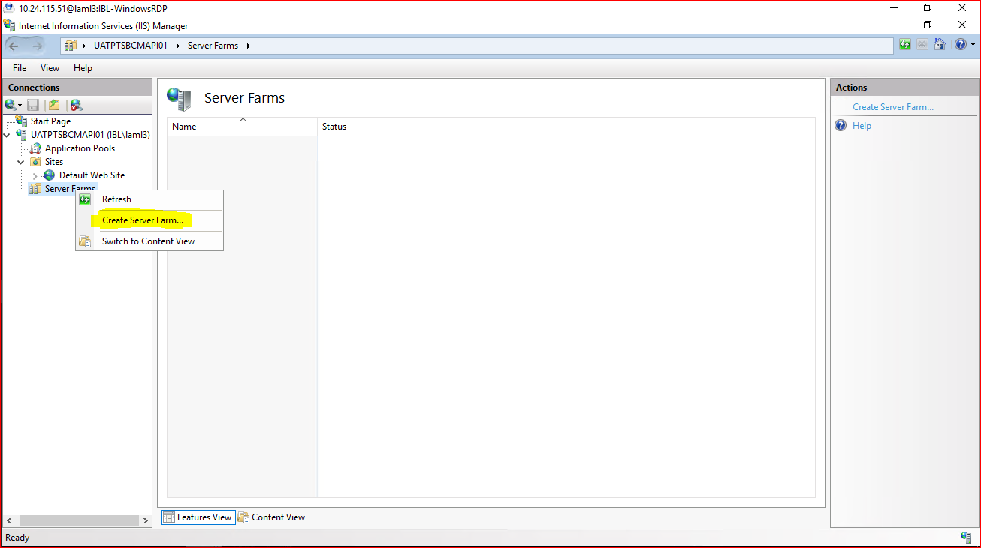

**Add Server Farms Name.**

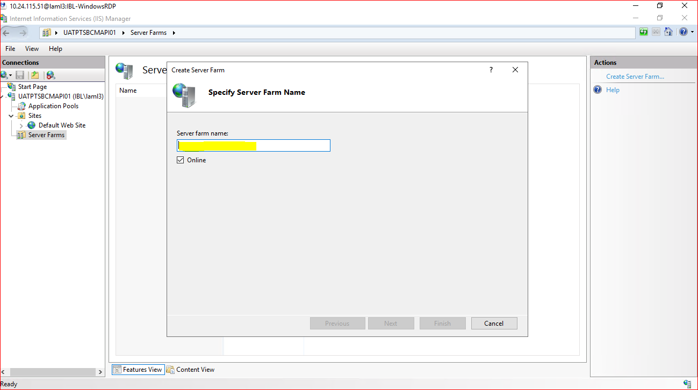

**Enter the Server Farms name Click Next button.**

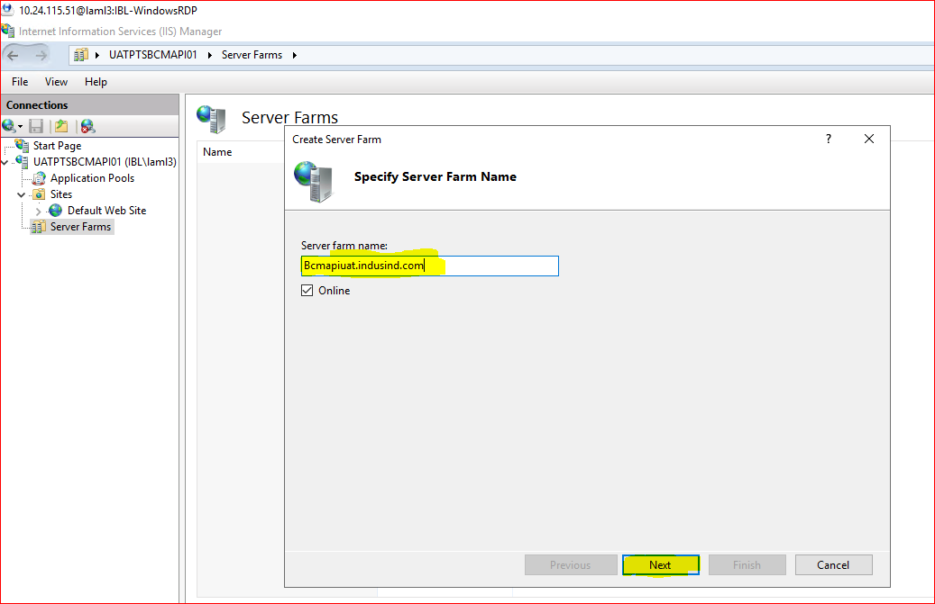

**Enter the Destination Server IP and Click Finish button.**

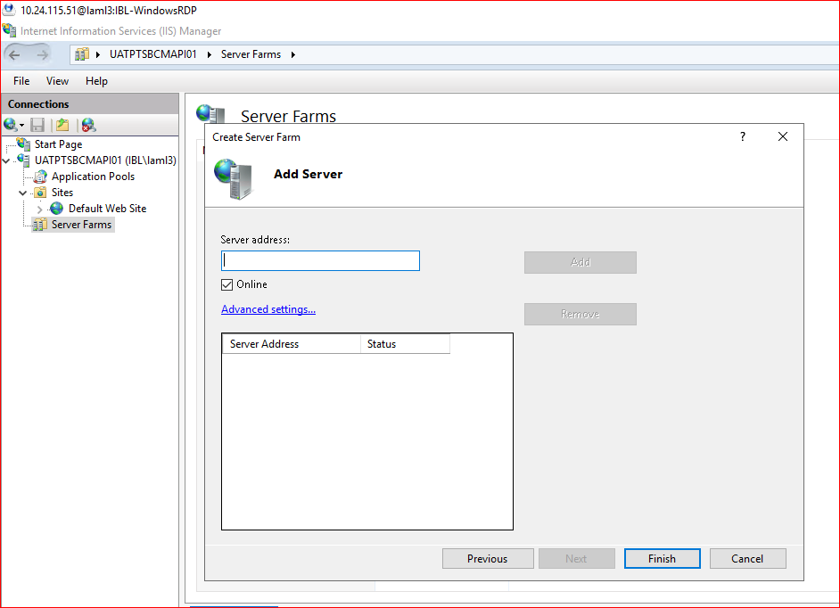

**Then Click on Yes button.**

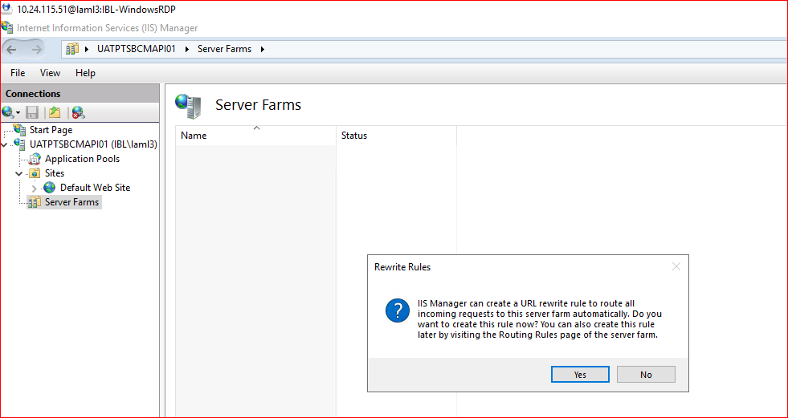

**Server Farms Created.**

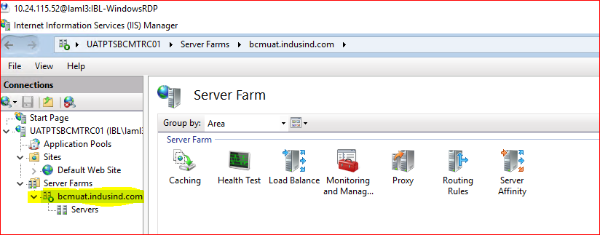

**Go to one by one configure the above settings.**

**Go to Caching and check the below setting is appear.**

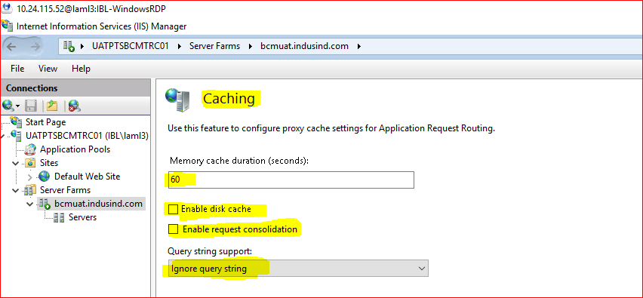

**You don’t have to configure Health test leave as It is.**

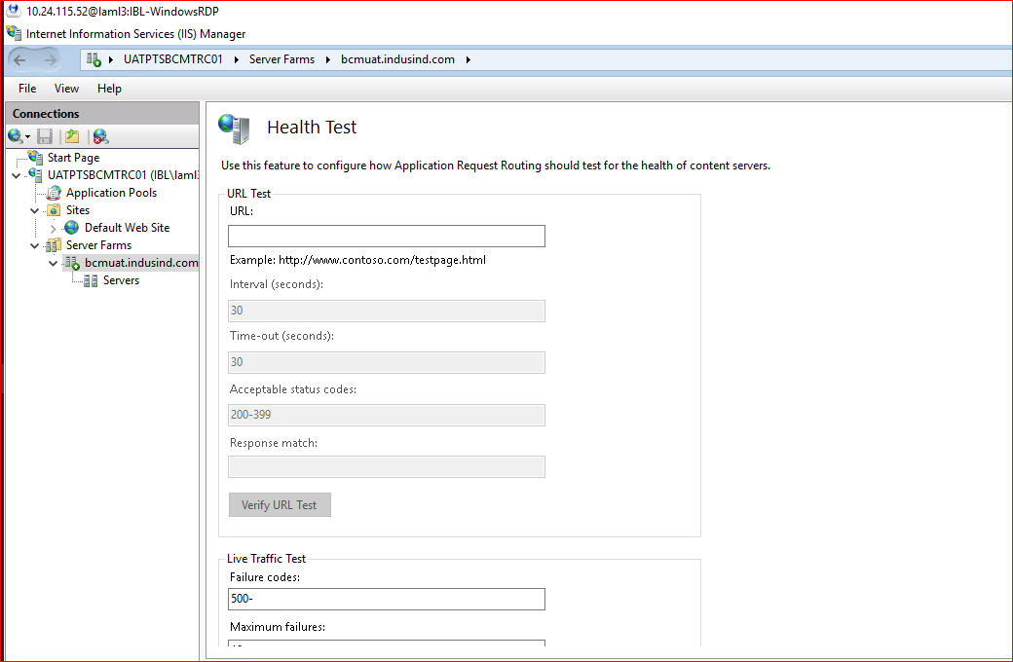

**Go to 🡺 Load Balance Tab and configure below Settings.**

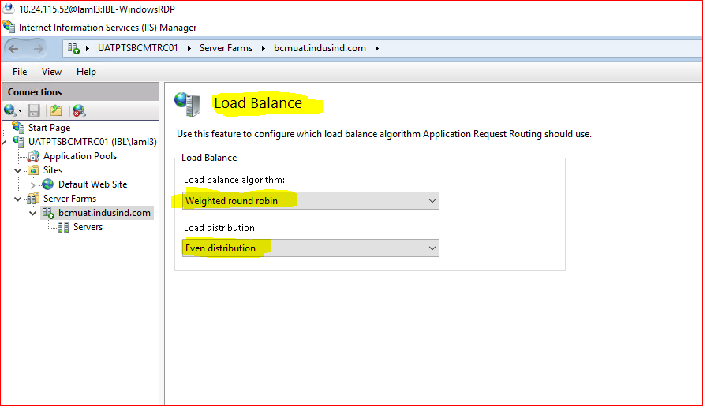

**You don’t have to configure anything monitoring and management tab.**

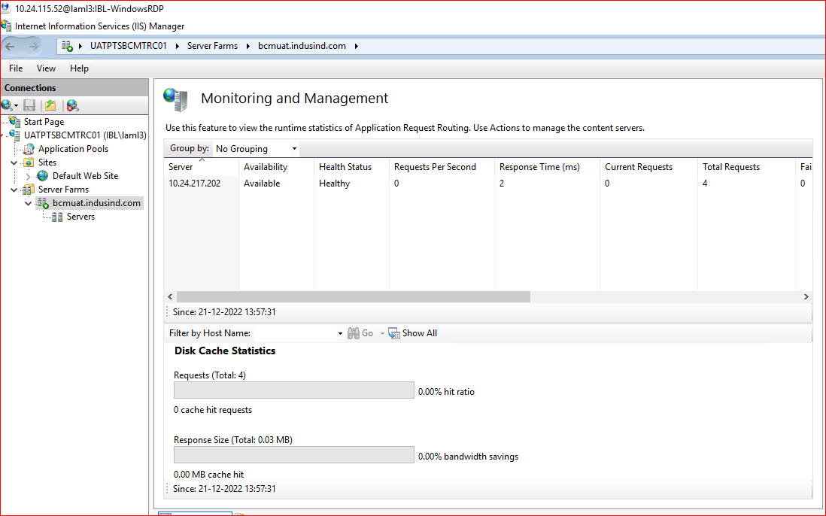

**Go to🡺 Proxy tab and configure below settings**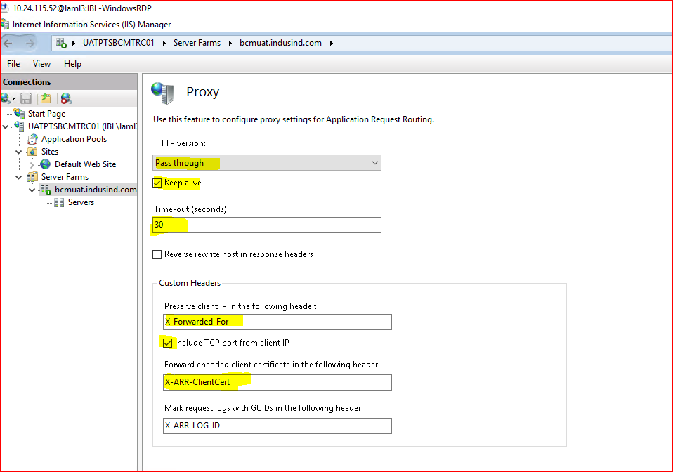

**Goto 🡺 routing rules and configure below settings.**

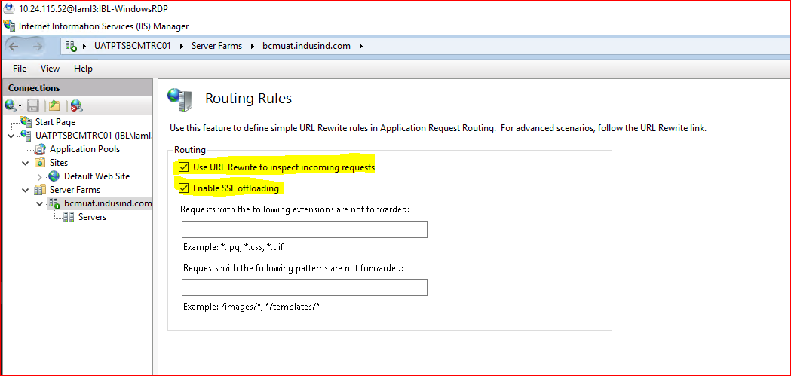

**Go to 🡺 Server affinity tab and configure below settings.**

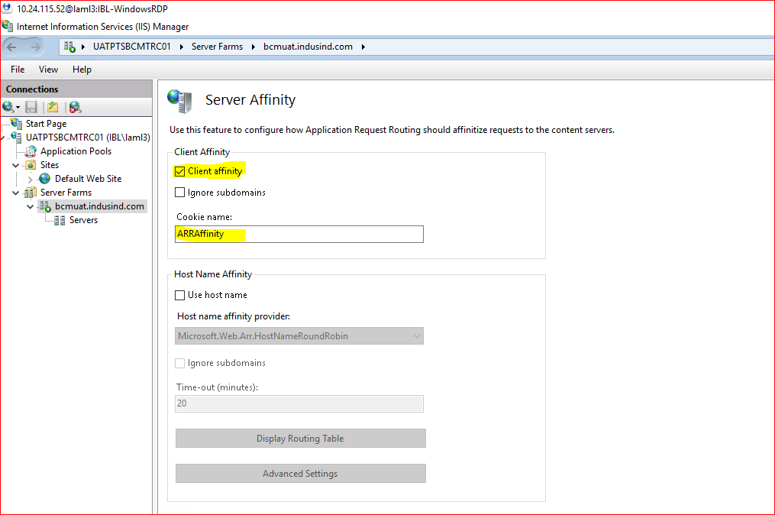

**ARR is configured in IIS.**